
9

NEWSLETTER 30th June 2023

Dear parents and carers

As we look forward to last two weeks of the summer term, we have been busy with a number of exciting activities this week starting with the wonderful Infant concert.

Our Infant classes provided us with a wonderful afternoon of music and drama on Monday in their Summer Concert. We heard some beautiful solo instrumental performances and poetry readings, as well as group performances from the Infant choirs, glockenspiels, and recorder groups. A particular highlight for me were the Boomwhackers which were played by the Infant One children, displaying their learning of complex rhythms.
Everybody performed so beautifully and professionally and I am so very proud of their achievements. Well done Infant 1 and 2 - we are lucky to have so much talent on display.

The Infant one children had a super trip to the Runway Visitor Park at Manchester Airport. They role-played various people who work at the airport, including pilots and firefighters, navigators and cabin crew.They learnt about the tworunways and all the different parts of the plane. Despite the weather they still had fun on the play area!

This week the children in Nursery and Reception have enjoyed a trip to Delamere Forest to complete the Gruffalo hunt. They enjoyed exploring the forest whilst following the story and finding each character. They also enjoyed following the interactive Zog trail. They came back with so many stories to tell and had the most amazing time.

This week, Prep 4 held Enterprise Week. Monday saw the selling of homemade cakes and biscuits – which all sold out very quickly! Then during the week there has been lots on offer: milkshakes, ice lollies, ice creams, pick n mix sweets and a penalty shootout.
On Wednesday and Friday children took part in craft activities – building wooden planes, creating calming bottles and wind spirals. The final activity, the sponging of the PE teachers, had to be postponed because of the bad weather. But do not worry it will take place next week! Prep 4 have worked very hard and they hope that the boys and girls in school have enjoyed what has been on offer and that they have had fun!

Next week sports day is on Frithday 7th July and parents are very welcome to attend, but I have been notified today by the college of an event which will also start in the afternoon at 1.45pm until 3.00pm. Please be prompt in order to get a parking space for our junior events.

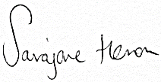

Ms Heron
Headteacher

SAFEGUARDING NOTICE
As mentioned in previous communication, we need your assistance with the Safeguarding of your children. Please can I ask that you close the gate after yourself if you are coming into school outside of school drop off and pick up.
If your child is late to school, please ensure they enter the building through the main entrance so that Mrs Ennis is aware of their arrival. Please DO NOT photograph or video the children in the playground as this is a safeguarding concern. We have parents who have not consented to their children being photographed or filmed.
Parents/Carers will not be allowed into school with their child in the morning. This is to safeguard everybody. Please drop your child off at the line in the playground or at the office.
We are aware that parking can be an issue, especially as the building work continues. Please can I remind you all not to park in the staff carpark and to park with consideration. Please ensure that you park up and walk your child into the playground.



WHAT’S ON - Dates for the Diary

WHAT | WHEN | WHO | NOTES
Lion King Performance | 4th July at 1.30pm | Parents and Carers invited | Tickets available on ParentMail from  16th June
Lion King Performance | 5th July at 6.00pm | Parents and Carers invited | Tickets available on ParentMail from  16th June
LAMDA Exams | 5th July | Candidates | N/A
LAMDA Exams | 6th July | Candidates | N/A
SPORTS DAY | 7th July | EYFS/Infants @ 9.30am  Juniors @ 1.30pm | Parents invited
PFTA Summer Party | Saturday 8th July  7pm til late | Parents/Staff | Tickets purchased via ParentMail
End of Year Mass  Holy Angels Church | Monday 10th July  2.00pm | Whole School | Parents invited to attend
Prizegiving  Holy Angels Church | Thursday 13th July 2.00pm | Whole School | Parents invited to attend
End of Term  school closed | Friday 14th July | Whole school | 12pm half day
INSET DAY | Monday  4th September | Whole School | School closed
INSET DAY | Tuesday  5th September | Whole School | School closed
School reopens  Autumn Term | Wednesday  6th September | Whole School | Winter Uniform to be worn
IntraHealth Flu Immunisations | Wednesday 18th October | All year groups (except PrePrep) | Consent letter to be sent via ParentMail in September

Transition Afternoon 6th July

We, as a school, recognise that transition is an important process. We want our children to experience smooth transitions so that the quality of learning is maintained and children continue to make the very best progress.
Before the children transition to a new year group in September, they will take part in a ‘meet the teacher’ transition afternoon. During the afternoon, children will partake in activities with their new teacher. These activities may include ‘getting to know you’ activities and teambuilding exercises. Please see the list below of class teachers for next year. Mrs Heald will be sadly leaving us at the end of this term as she prepares for the arrival of her baby.
Intake September 2023 | Teachers Name
Nursery/Pre-Prep | Mrs Clarke/Miss Heywood
Reception | Mrs O’Sullivan
Infant 1 | Mrs Conroy
Infant 2 | Mrs Davies
Prep 1 | Miss Aldridge
Prep 2 | Mrs Fielding
Prep 3 | Mrs Cooke
Prep 4 | Mrs Ellis



STARS OF THE WEEK!
If a pupil in the previous week has done something special in class
that sets them apart from the other pupils their teacher will award them with star of the week.
The stars of each week will be treated to a hot chocolate or juice with the Headteacher on Friday to congratulate them on their fantastic efforts. If a pupil has achieved something outside of school and wishes to bring the item to Wednesday’s celebration assembly they are more than welcome to do so.

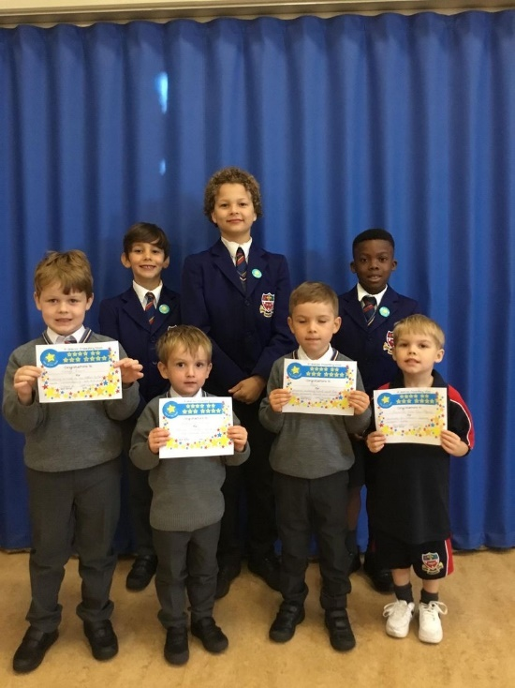
INFANT 1:Thomas for always being a kind friend, being a motivated learner and always trying his best.

INFANT 2: Frank who brought in a lovely piece of work he had completed at homeabout Amelia Earhart, well done!

PREP 1: Antoni for giving his best at every opportunity, being accurate, checking his work, presenting his written work beautifully and taking pride in everything he does.

PREP 2: Akaal and Jackson. Akaal has taken on the role of class teacher this week to help teach our class all about Sikhism. He has been doing a wonderful job. Jackson has continued to show determination and resilience in all that he does, whilst always smiling too. Keep up the great work!
PREP 3: Harrison for being a lovely class mate and firend to everyone, always polite with a smile. He works really hard always, using our motto ‘your dictionary is your best friend’
PREP: 4 Pietro is star of the week for being resilient. Pietro has had a couple of bad injuries recently but he has persevered and done his best. He has such a positive attitude and always comes to school with a huge smile on his face. Well done!


Edmund’s Footstep’s Award
This week’s recipients of our ‘Edmund’s Footsteps Award’ nominated by their peers, are Rory and Joses
Rory was nominated by William for always trying his hardest in everything he does.
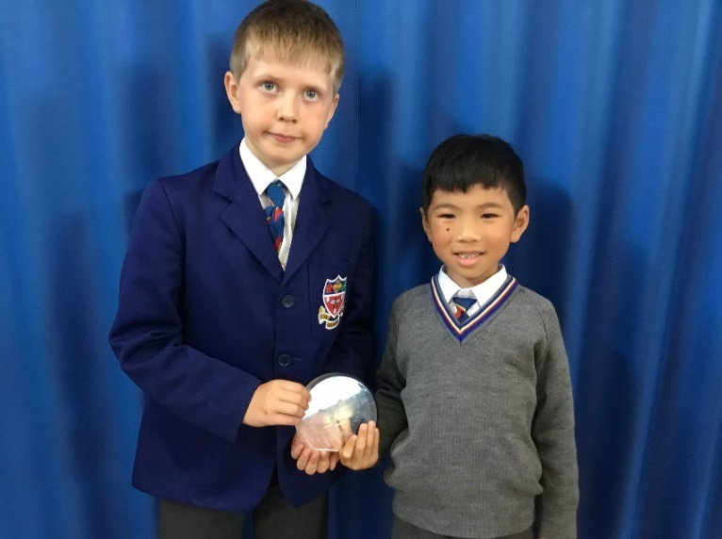
Joses was nominated by Gabriel for sharing and playing with everyone!



Hot Lunch Menus – updated v2

